Record of the Public Hearing for the Good Samaritan CDBG Public and Community Facilities Grant Application
September 3, 2020 at 12:00 pm
Virtual Hearing via Zoom at https://zoom.us/j/98318053443

For a copy of the hearing’s presentation and a complete recording of the Public Hearing visit: https://www.lccountymt.gov/cdp/grants-program.html

Hearing Attendees:
Project Members:
Ann McCauley, Lewis and Clark County
Michael Dowling, Dowling Architects
Bill Grant, Dowling Architects
Laura Erikson, Stahly Engineering
Robie Culver, Stahly Engineering
Theresa Ortega, Good Samaritan Ministries

Members of the Public
Brianna
Brian Garrity
Erin Olson
Heather Hudson
Jack Berry
John Ries
Marvin
Matt Furlong
Matthew Paulsen, Allegra
Mary Bell
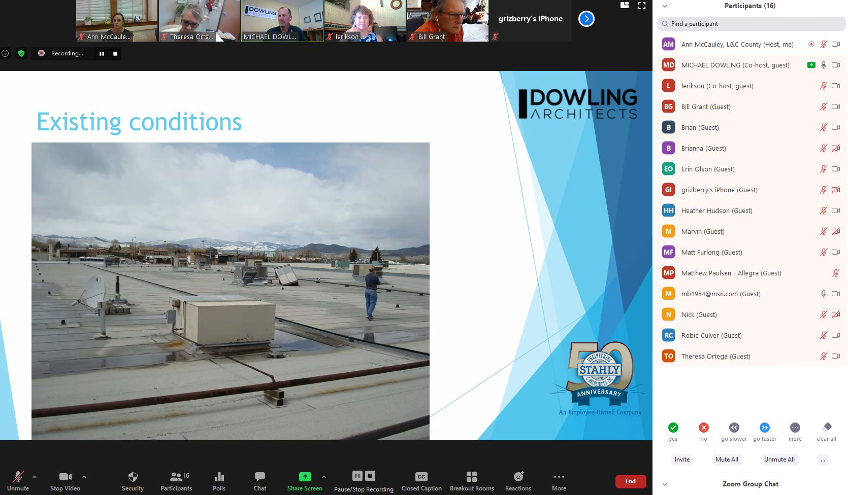
Nick
Snapshot of Zoom screen during Public Hearing Presentation showing attendee list. John Ries joined the meeting after this snapshot was taken.
Hearing Summary:

Ann McCauley, Lewis and Clark County Grants Administrator, opened the hearing at 12:00 p.m. Ann gave a brief background to the purpose of the CDBG program, the role of the County in the CDBG program, and the purpose of this hearing.

Theresa Ortega, Good Samaritan Ministries Executive Director, spoke about the mission of Good Sam and the history and need for the proposed project.

Mike Dowling, Principle for Dowling Architects, then presented a summary of the prepared Preliminary Architectural Report (PAR), including the preferred alternative and the three tasks of the project: a new roof, updated HVAC, and shelving for the receiving and sorting area.

Laura Erickson, Stahly Engineering Grant Writer, presented on the funding and CDBG grant application components of the project.

Concluding Laura’s presentation, the hearing was opened up for public comment at ~12:23 p.m.

Written Public Comment:

Two attendees provided written comment in Zoom’s Chat feature; these comments are below.

From Matt Furlong to Me: (Privately) 12:20 PM
HI Ann, I am not able to stay on the meeting toady, but came in support of needed upkeep. I am an executive member of the Behavioral Health Local Advisory Council in L&C. When Western Montana Mental Health pulled out of our community last year, GSM stepped up at their MT avenue location, staffed the Our Place Drop-in Center, and has aided our community through Covid as a leader in service to those in need. They serve in the trenches every day for those in need in a way that actually helps improve the quality of life, and reduces the cost of higher level care, and adversity from unmet needs. I highly recommend considering all upkeep repairs needed for GSM as an investment that gives a substantial ROI. Please add my comments to the list of support for these needs. Thank you,

From Matthew Paulsen - Allegra to Everyone: 12:32 PM
I think the plan that's laid out is very detailed, and a very make-sense approach. And ensures that Good Samaritan can continue its operations and grow. The roof is a necessity and the storage shelving will only help with efficiency. I'm all for it and will do what I can to help generate support and donations to make this project happen. Great work.

Oral Public Comment:
The following four attendees provided oral comment. A summary of oral comments are below.

Jack Berry, GSMS Treasurer and Community Member

Brian Garrity, Community Member

Heather Hudson, GSMS Interim Fiscal Manager

Mary Bell, GSMS Board Member

